Education
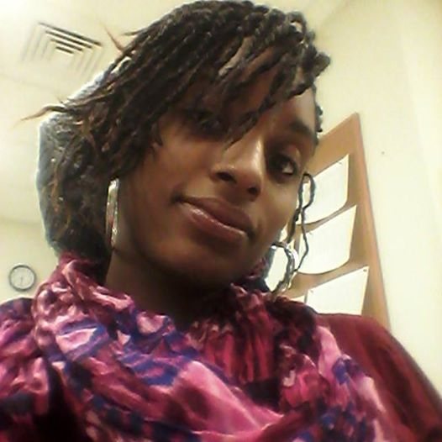

Yahmina Bryant
  - Creative copywriter

Professional Summary
Highly motivated, creative, and culturally connected copywriter with multifaceted experience in customer service, advertising, media publication, fashion, and branding.

Skills & Abilities
- Photoshop/Graphic Design
- Storytelling (poetry, short stories, articles etc.)
- Web Creation & Design
- Business Stationary Design/ Formatting
- Experienced in all Microsoft Office Software
- Talent Scouting
- Public Relations
- Campaign Development
- Manuscript Formatting for print
- Publishing/Proof Reading/Editing
Vitals
301 Avon Ave
Newark, NJ 07108
T 973-980-1650 (Cell)
H 862-298-8350 (Home)
E wbcnotaryservices@gmail.com
NEWARK TECH HIGH SCHOOL, NEWARK, NJ

September 2004 – JUNE 2008
- College Preparation Studies
- Certificate in Carpentry
ESSEX COUNTY COLLEGE, NEWARK, NJ

September 2011 – JUNE 2013
- A.S. Degree in Journalism
- Certificate in Customer Service

PROFESSIONAL CERTIFICATES
New Jersey Notary Public
- Provide Notary services for New Jersey residents
- Certify documents

Community Accesses Unlimited
- Certificate in Preventing Abuse & Neglect

work history

Freelance Copywriter, Newark, nj

June ‘16 – pRESENT
Developing creative content (i.e. articles, newsletters, taglines, flyers, etc.) that can be presented through multimedia outlets; which enhances the engagement of the client’s audience. Building stationary for networking and advertising during social outings. Clients: Kee Multimedia, Urban Times Newspaper, Poetic Treasures Magazine.

Barnes & Nobles Affliate, lIVINGSTON, NJ

September ’14 – June ‘16
Organizing custom book fairs and book signings for non- profit organizations and upcoming artist of all genres. Organizes sales floor to produce effective optimizations of store sales. Clients: Kee Multimedia & Writer’s Block Café Art Organization

Freelance Public Relations Rep, newark, Nj

September ’04 – June ‘14
Worked with client on tight deadlines as support personnel; while helping with promotional content, correspondence emails, and messaging. Consistently promoting previously written or upcoming public speaking engagements. Appeared at public readings and assisted in public and private book signings/meetings. Attended interview sessions with the client face-to-face and over the telephone. Provided workshops for client designed to improve and build upon writing skills.
Clients: Kimani Tru Publication, Assemblywoman Tucker, East Orange P.A.L., New Community Corporation.

ACTIVITES & INTEREST

Author
Urban Literature
Poetic Treasures Magazine
Anthology of Poetry
Fashion
Tailor
Sewing Class Instructor
Fashion Designer/Illustrator
Non- Profit Organization

Proud Incorporator/Director of Writer’s Block Café Art Organization

Workshops & Events
Host Bi- Weekly Art & Poetry Events
Book fairs
Book signings
Mommy & Me Book clubs
Creative Writing workshops
Community Outreach

References

Blog Site: https://writersblockcafeart.wixsite.com/cafetalk

Magazine Link: http://online.fliphtml5.com/tufm/negr/

